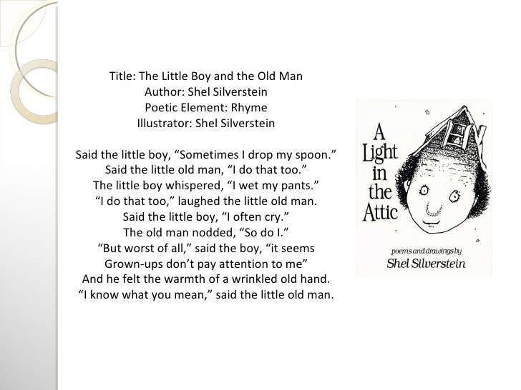

Name________________________________________________

1. What is the underlying message that is being conveyed in this poem?

2. Has Shel Silverstein used any particular poetic technique that brings out this message more clearly?

3. Do you feel that grown-ups don’t pay attention to you? When?

4. How does this theme of Human Relationships fit into the CNA curriculum?

5. Complete the following 2 verses of the poem thinking about your life and your relationship with grandparents, an older person in your life.

Said the _____, "Sometimes __________________."
Said the __________, "I do that too."

Said the _____, "Sometimes __________________."
Said the __________, "I do that too."

